Directors, welcome to Sparkhouse Online!
Sparkhouse Online makes it easy to plan your Sunday school program.
To download content after you plan classes or an event, follow the directions below:
(For more information on planning an event see the Getting Started with Planning help sheet.)

Begin by signing into Sparkhouse Online:
- Go to the Sparkhouse Online login page: http://sundayschool.sparkhouseonline.org
- Enter your email address and password in the “Returning Users” box and click “Log In”.
- Complete your profile information and click “Save”.

Downloading content for a single event:
- Click on the name of an event on your home page.
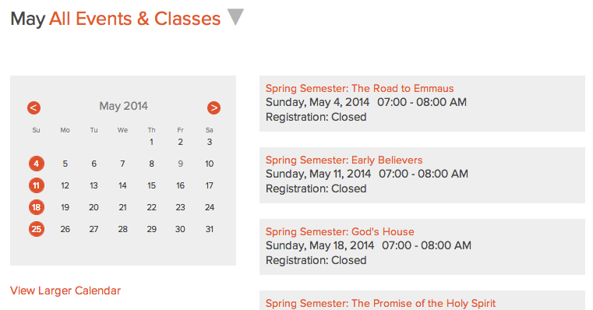
- On the Event Planning page, click on the “Back to Overview” link. 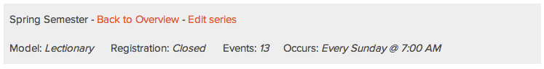
- From the Series Overview list, click on the Details link on the event for which you want to download content.

- Download! You’re Done!

