Getting Started: Using the Spark Online Library
Spark Online makes it easy to find lesson resources in the Library.
To get started using the Library, follow the directions below:

Ack! What’s the fastest way to download lesson files from the Library?
- Go to the Library.

- In the Filter Lessons Panel, click on the model, quarter, Bible story, and age level you will be leading or teaching (for those using the rotation model, the layers are a bit different).
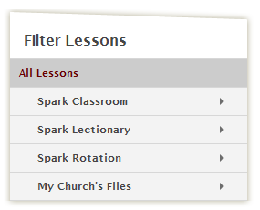

- Check the “Select All” box at the top of your search results.
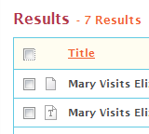

- Click the download button—all the files for the lesson will download together in a .zip folder.
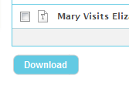

Other Library Tips and Tricks?
Search Results: Any time you conduct a search or apply a filter in the library, your results will be organized by Bible story in scope and sequence order. For churches who subscribe to all curriculum models, results are organized by model (Classroom, Lectionary, Rotation), and then by scope and sequence.

Advanced Options: The Advanced Options panel makes it easy to filter by specific kinds of resources. We’ve also added more advanced options make it easier to find lesson resources.
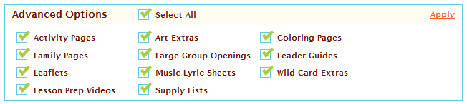

Filter Lessons Panel: Use the Filter Lessons Panel to find materials or resources for a particular quarter or story. You can even drill down to specific age levels or workshops!
