Directors, welcome to Spark Online!
Spark Online makes it easy to plan your Sunday School program.
To download content after you plan an event, follow the directions below:
(For more information on planning an event see the Getting Started with Planning help sheet.)

Begin by signing into Spark Online:
- Visit your congregation’s custom Spark Online URL:
http://YourChurchSign-InPageURL.sparksundayschool.org
- Enter your email address and password in the “Log into Spark” box and click “Log In”.
- Complete your profile information and click “Save”.

Downloading content for a single event:
- Click on the name of an event on your home page.
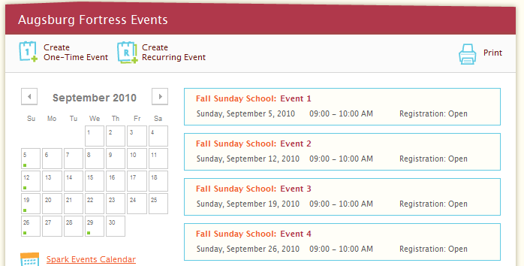
- On the Event Planning page, click on the series overview link. 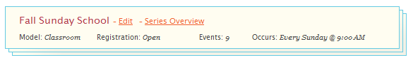
- From the Series Overview list, click on the Details link on the event for which you want to download content.
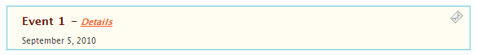

- Download! You’re Done!
