Leaders, welcome to Spark Online!
Spark Online makes it easy to prepare for Sunday School.
To get started with class preparation, follow the directions below:

Begin by signing into Spark Online:
- Visit your congregation’s custom Spark Online Sign-In Page:
http://YourChurchSign-InPageURL.sparksundayschool.org
- Enter your email address and password in the “Log In to Spark Online” box and click “Log In”.
- Complete your profile information and click “Save”.

Downloading Content for an Event:
- Click on the name of an event in the My Spark Events module on your home page.
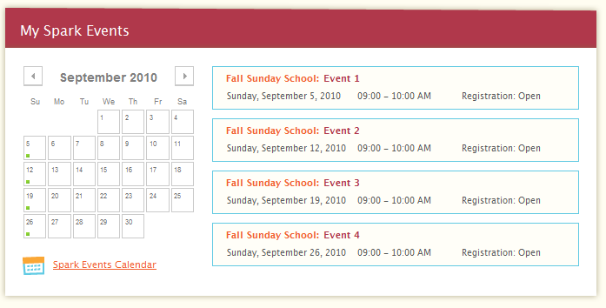

- From the Series Overview list, click on the Details link on the event for which you want to download content.
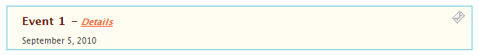

- The Event Details page will show you the both role to which you’ve been assigned, and the files you will need for the event. Download--You’re done!
