Directors, welcome to Spark Online!
Spark Online makes it easy for Sunday school parents to register their kids.
To get started with site access and event registration, follow the directions below:

Begin by signing into Spark Online:
- Visit your congregation’s custom Spark Online Sign-In Page:
http://YourChurchSign-InPageURL.sparksundayschool.org
- Enter your email address and password in the “Log In to Spark Online” box and click “Log In”.

Site Access and Event Registration Basics:
- Spread the word—distribute your church’s custom Spark Sign-In Page web address to your Sunday School parents and leaders. They can go to the site to request site access.
Don’t know the address of your Sign-In Page?
  - Click on Admin in the main site navigation. 
  - Your Sign-In Page address is located in the Edit Account Info area, under the name of your church or organization.
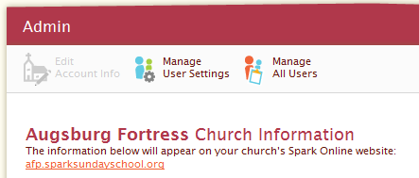
- Approve Leader and Parent Users--When Leaders and Parents register for site access, you will be notified on the Home page that they need approval.
  - Click on the alert to approve new site users. 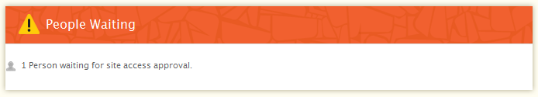
  - This will take you to the Admin area of the site. Select the site access level for each new user and then click the check mark to confirm. 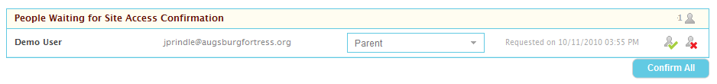
- Assign Registered Kids Into Groups
  - If you have opened events for registration, parents can register kids by clicking on the event in the registration box on the Home page
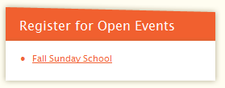
  - Once kids are registered, notification will appear on your home page. Click on the name of the event to go to the planning area, click the people waiting message to put new registrants into groups. 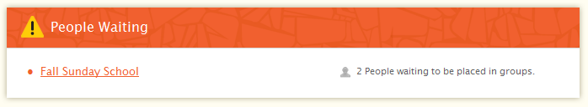
- What will Parents See?
When parents of registered kids sign-in to Spark Online, they will see the events listed on their home page.
